**Program - 5**

**Aim:**

Program to implement Naïve Bayes Algorithm using any standard dataset available in the public domain and find the accuracy of the algorithm

import pandas as pd

from sklearn.model_selection import train_test_split

from sklearn.preprocessing import StandardScaler

from sklearn.naive_bayes import GaussianNB

from sklearn.metrics import confusion_matrix,accuracy_score

dataset=pd.read_csv('Social_Network_Ads.csv')

x=dataset.iloc[:,[2,3]].values

y=dataset.iloc[:,-1].values

x_train,x_test,y_train,y_test=train_test_split(x,y,test_size=0.30)

sc=StandardScaler()

x_train=sc.fit_transform(x_train)

x_test=sc.transform(x_test)

classifier=GaussianNB()

classifier.fit(x_train,y_train)

y_pred=classifier.predict(x_test)

print(y_pred)

ac = accuracy_score(y_test,y_pred)

print(ac)

**OUTPUT**

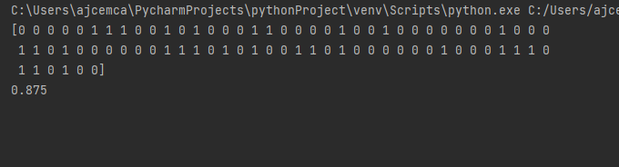

**Program - 6**

**Aim:**

Program to implement linear and multiple regression techniques using any standard dataset available in the public domain and evaluate its performance.

**Program(inbuilt):**

import numpy as np

import matplotlib.pyplot as plt

from sklearn.linear_model import LinearRegression

x=np.array([5,15,25,35,45,55]).reshape((-1,1))

y=np.array([5,20,14,32,22,38])

print(x)

print(y)

model=LinearRegression()

model.fit(x,y)

r_sq=model.score(x,y)

print('coefficent of determination: ',r_sq)

print('intercept: ',model.intercept_)

print('slope : ',model.coef_)

y_pred=model.predict(x)

print('Predicted response: ',y_pred)

plt.scatter(x,y,color="g")

plt.plot(x,y_pred)

plt.xlabel('x')

plt.ylabel('y')

plt.show()

**OUTPUT**

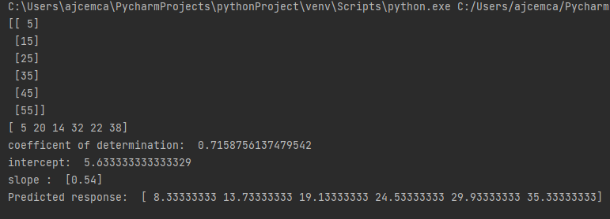

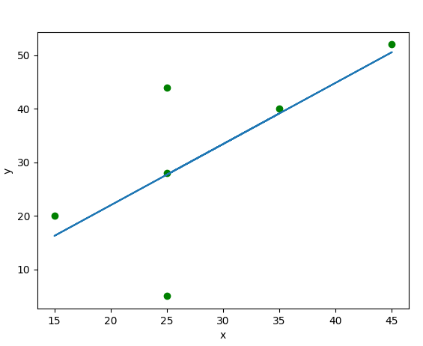

**Program(Without inbuilt):**

import numpy as np

import matplotlib.pyplot as plt

def estimate_coef(x,y):

n=np.size(x)

m_x=np.mean(x)

m_y=np.mean(y)

SS_xy=np.sum(y*x) - n *m_y* m_x

SS_xx=np.sum(x*x) - n *m_x* m_x

b_1=SS_xy / SS_xx

b_0=m_y - b_1* m_x

return (b_0,b_1)

def plot_regr_line(x,y,b):

plt.scatter(x,y,color="m",marker="o",s=30)

y_pred=b[0]+b[1]*x

plt.plot(x,y_pred,color="g")

plt.xlabel('x')

plt.ylabel('y')

plt.show()

def main():

x = np.array([0, 1, 2, 3, 4, 5, 6, 7, 8, 9])

y = np.array([1, 3, 2, 5, 7, 8, 8, 9, 10, 12])

b = estimate_coef(x, y)

print("Estimated coefficients:\nb_0 = {} \

\nb_1 = {}".format(b[0], b[1]))

plot_regr_line(x, y, b)

if __name__=="__main__":

main()

**OUTPUT**

